TRS Updates for NY Payroll/July Payroll Corrections

TRS released an updated Statutory Minimum table Friday afternoon. Since so much has changed due to HB 3 related to TRS, the following should ensure nothing has slipped through the cracks. The steps in this document should be completed to correct Budget and to make corrections to July’s RP report to TRS for those districts who have already processed July payroll. If you have additional questions, feel free to call or to attend our workday on July 31 for one-on-one assistance. Please sign up for the workday on our website to help us ensure adequate staffing.

For those who have ALREADY processed July payroll

Log onto NY Payroll

- From Tables > Tax/Deductions > TRS Rates tab, retrieve School Year 2020. Enter/edit the rates to show the following and Save.

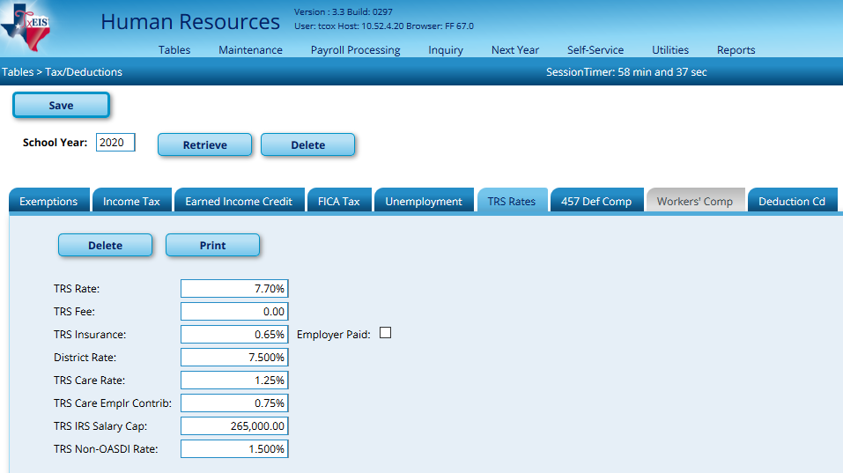

- Save the new Stat Min table (StatMin_2020) to your computer. From Utilities > Install Salary/Tax Tables, select State Salary and Next Year. Browse to the StatMin_2020 file and Submit.
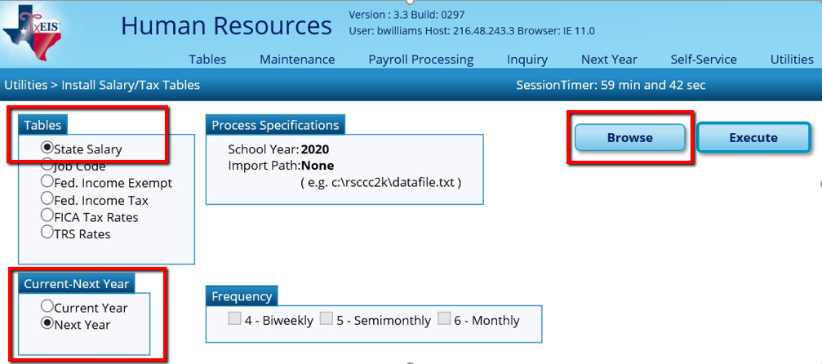

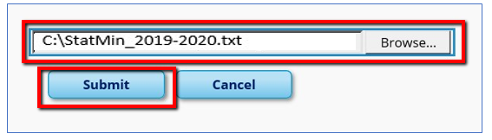

Click Execute, then Process at the Preview.

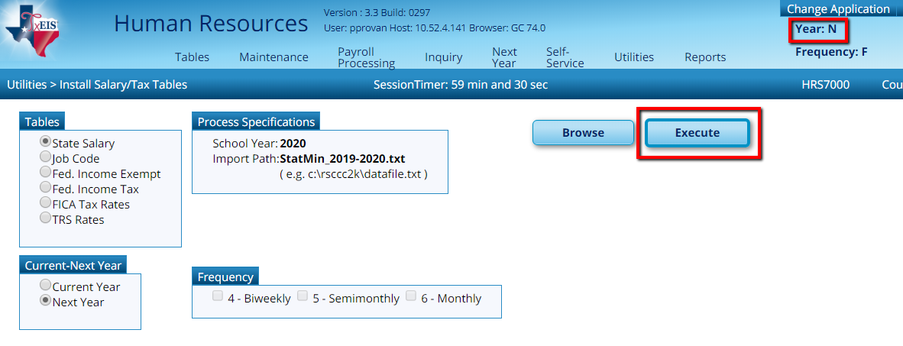

A message will display asking if you wish to replace existing records. Select Yes and the tables will be updated successfully.

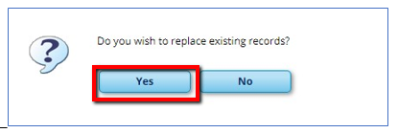

- If applicable, re-activate 12 month employees in NY Payroll, then calculate the Stat Min on applicable employees.

If 12 month employees have been moved to Current Year Payroll, they may be inactive in NY Payroll. They should be active for Stat Min calculations. If you need to reactivate these employees, go to Utilities > Mass Update > Employee tab. Select Pay Status Inactive and the applicable Extract ID. Reset the Pay Status to Active in the first column below. Execute. Repeat for additional Extract IDs as needed.

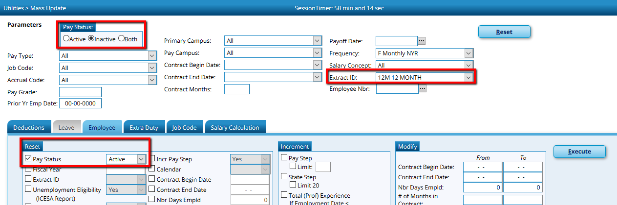

Calculate Stat Min on all applicable employees from Utilities > Mass Update > Salary Calculation tab. Select State Minimum Only. If you have employees who work less than 100% of the day and who are subject to Stat Min, check the box to Apply Percent of Day Employed. Execute.

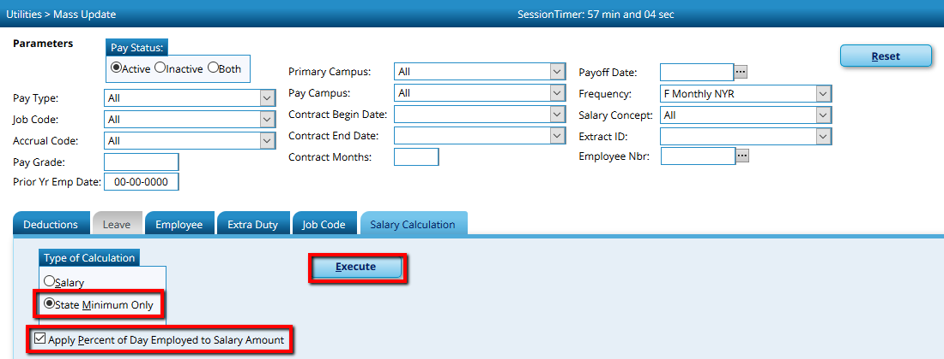
An error listing may display. If employees should be subject to Stat Min, you should Cancel and correct the error(s), then repeat this step.

- From Tables > District HR Options, update the Cost of Education Index to 1.0. Save. Please take note to what the CEI Rate was initially as we will need to change it back in a later step.

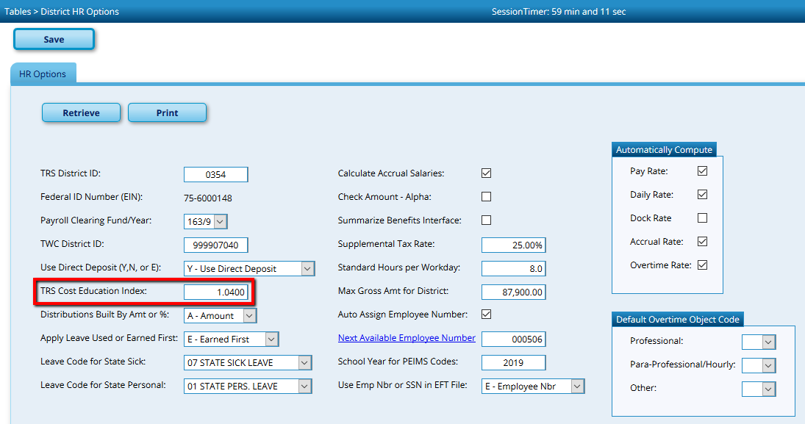

- From Next Year > Interface NY Payroll to NY Budget, enter the TRS On-Behalf Expenditure Account options, move all employees to the right and select Run.

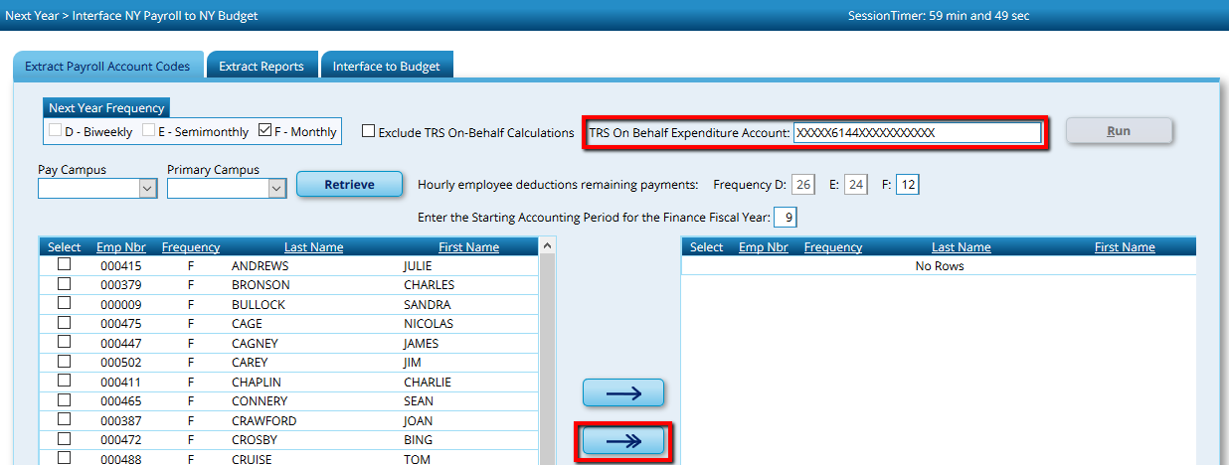

An Error Listing will be displayed. Employees with Fatal errors will be excluded from Budget calculations. Those with Warnings, will be included but may not be accurate. Close the report.

Proceed to the Extract Reports tab and review reports for accuracy.

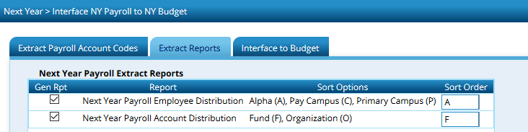

Proceed to the Interface to Budget tab and Interface to Requested, Recommended or Approved in Budget as desired.

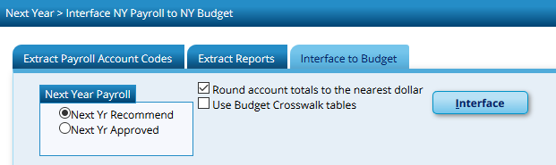

Note: These steps can be repeated as necessary, however special care should be used to ensure the correct employees are included and the CEI Rate is set to 1.0 on the District HR Options Table when calculating amounts for the 2019-2020 Budget.

- From Tables > District HR Options, change the Cost of Education Index back to its original index and Save.

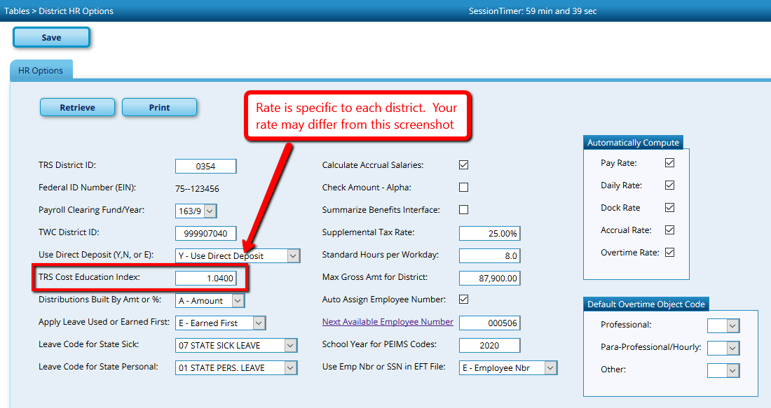
Reminder: Any time you are budgeting payroll amounts for 2019-2020, the Cost of Education Index should be set to 1.0. When calculating payroll for July and August, the index should be set to the rate applicable to your district. Because the District HR Option table is shared between Current and Next Year Payroll, special attention will need to be paid to ensure proper amounts are calculated.

- Update the State Minimum Salary manually on 12 month employees to Current. Run a User Created Report to show the new State Minimum Salaries. From Reports > User Created Reports > HR Report, select First and Last Name, Extract ID (or Contract Begin Date if not using Extract IDs) and State Minimum Salary. Sort/Filter as needed to reduce the list to 12 month employees and print.

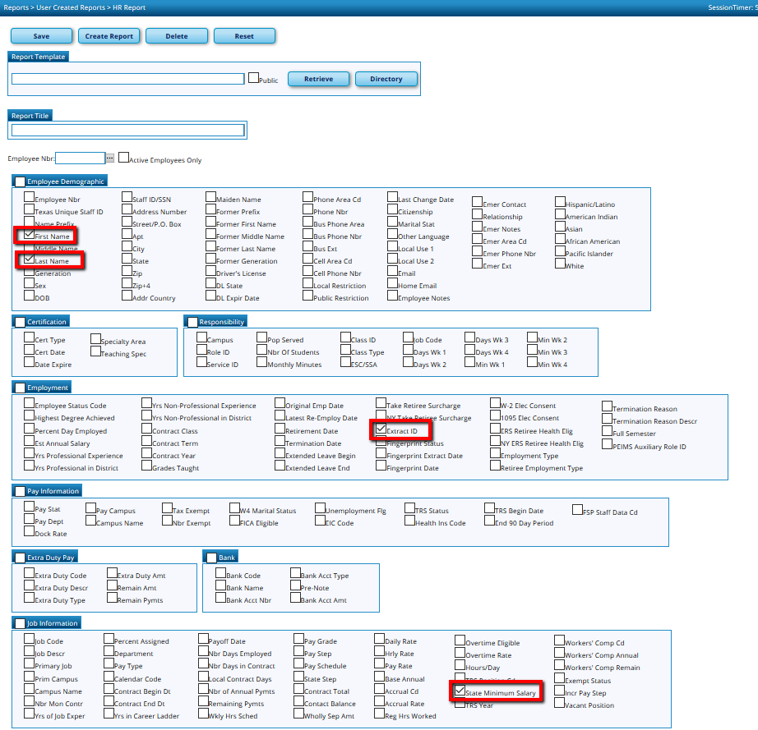

Change to Current Year Payroll

From Maintenance > Staff Job/Pay Data > Job Info tab, change the State Min Salary to match the amount calculated in NY Payroll so the Stat Min contribution will be accurate going forward. Repeat for all 12 month administrators, counselors, athletic directors, etc… who are subject to Stat Min and have already received their first check of the new contract year. Support Staff will not need to be changed.

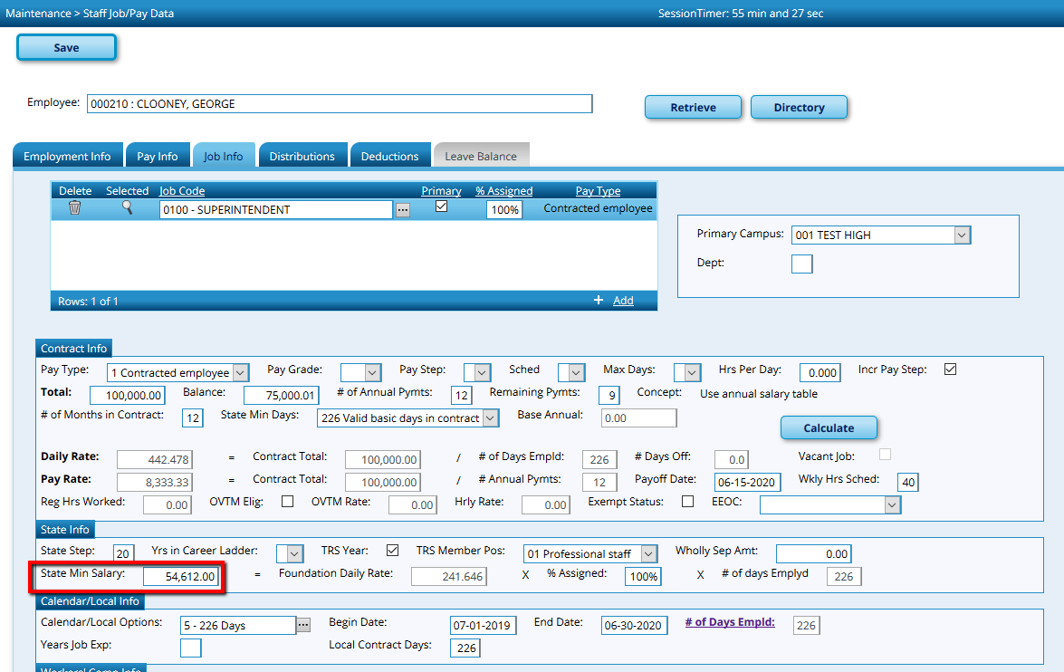

When it is time to create your TRS files to send to the RE Portal, some additional corrections will be required this month. The initial extract of the RP will show the State Minimum Salary that was in the Job Info screen at the time payroll was processed. However this can be adjusted manually from Payroll Processing > TRS Processing > Payroll History tab. Retrieve a 12 month employee subject to Stat Min. Enter the same annual amount entered into their Job Info screen in the previous step into the Annual State Minimum Salary field. Then divide that amount by 12 and enter the monthly amount in the Period State Minimum Salary field and Save.

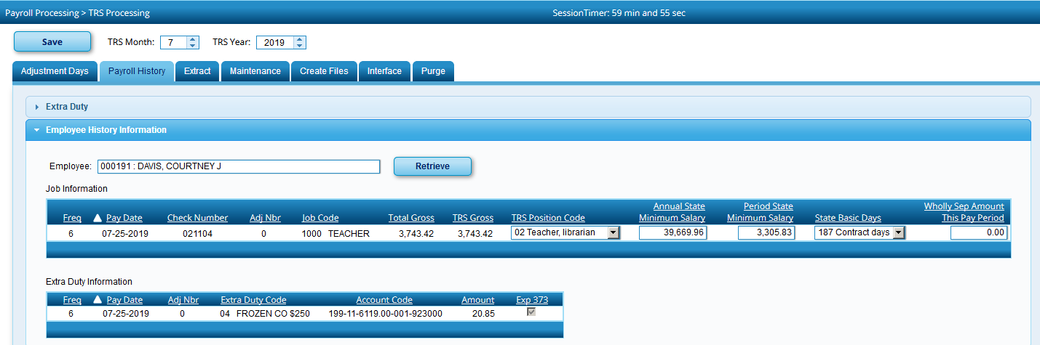

From Payroll Processing > TRS Processing > Extract tab Re-extract the RP, choosing to Delete All and Insert New Records. You may extract all files if desired, but at a minimum you must re-extract the RP.

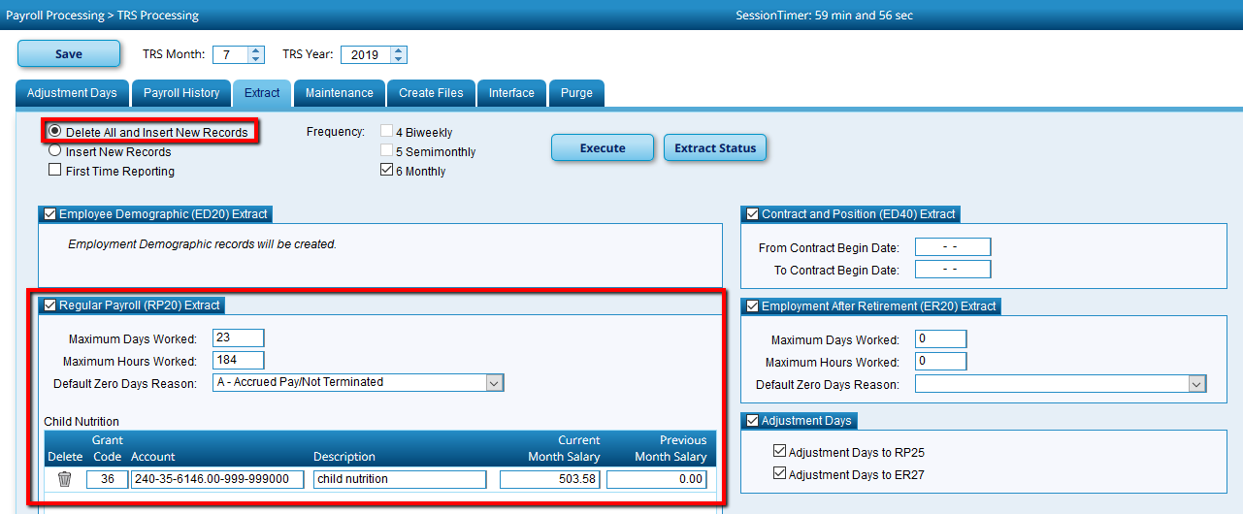

When you are ready to Interface, Refresh to ensure the proper Stat Min amounts are interfaced to Finance.

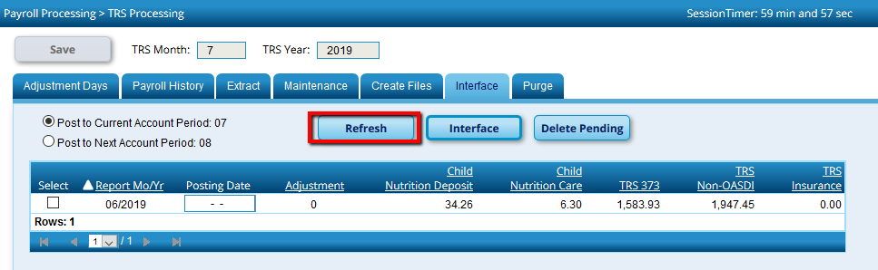

Note: This should be the only time you have to make manual corrections, as long s the State Minimum Salaries were updated on each Job Info screen.

